**Natural gas Production Trends in Bangladesh: A Study of**

**the possibility of a natural gas energy crisis in the future.**

This study analyses the trends in the production of natural gas in Bangladesh, which is experiencing a declining output and a rising demand coupled with dependence on key fields like Titas and Bibiyana. It highlights challenges related to costly LNG imports and emphasizes that new gas discoveries and renewable energy are imperative for sustainable energy planning.

|  |  |  |
| --- | --- | --- |
| Year | Gas Production(Bcf) | LNG importation(Bcf) |
| 2014 | 820 | 0 |
| 2015 | 890 | 0 |
| 2016 | 971 | 0 |
| 2017 | 972 | 0 |
| 2018 | 961 | 0 |
| 2019 | 965 | 116 |
| 2020 | 887 | 203 |
| 2021 | 892.76 | 216.1 |
| 2022 | 842.01 | 240.56 |
| 2023 | 803.63 | 203.41 |

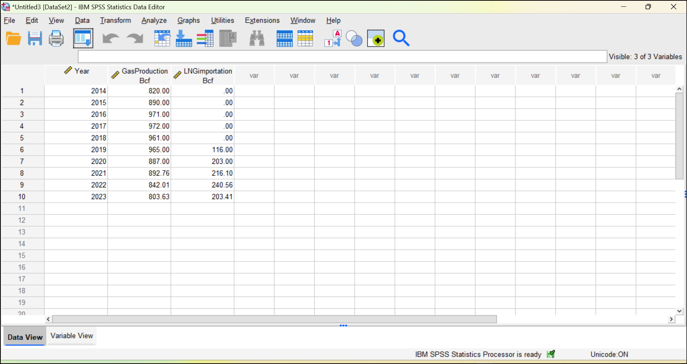

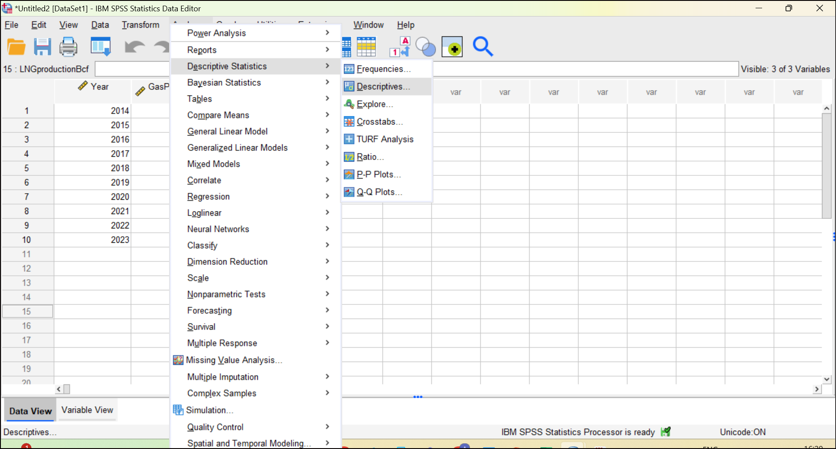

Our data shows that Bangladesh's natural gas production peaked in 2017 with outputs of 972 Bcf and has been decreasing gradually since then, reaching 803.63 Bcf in 2023. LNG imports started in 2019 and significantly increased to fill the gap, peaking at 240.56 Bcf in 2022. This indicates an increasing dependence on LNG supplies due to falling domestic production.